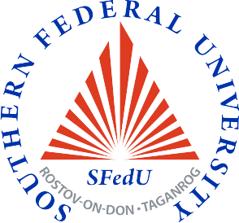  http://www.sfedu.ru | Masters Programme  “Nanoscale Structure of Materials” | 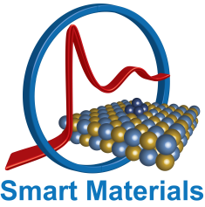  http://nano.sfedu.ru/

Masters Degree Programme: offered by Southern Federal University (http://sfedu.ru/index_eng.php)
Study Locations: The Smart Materials Research Center (http://nano.sfedu.ru/), Southern Federal University, Rostov-on-Don, Russia
Type of the course: full-time
Length: 2 years
Number of ECTS credits: 120 ECTS credits
Language required: English
Entrance exam: Physics
Admission documents for international applicants:
- Passport and its translated version (translation must be done either at the Consulate or in Russia with a Russian notary)
- Official University transcripts with Russian translations: Your application needs to include all official and original academic records from college or university you have attended (at least Bachelor’s degree).
- Medical certificate
- Certificate of absence of HIV infection
- 6 color photos (3x4 cm)
For more details follow: https://sfedu.ru/www/stat_pages22.show?p=STE/N12362/P
Head of the Masters Degree Programme: Professor Alexander V. Soldatov (http://nano.sfedu.ru/structure/staff/soldatov/?CODE=soldatov )
Objectives of the Masters Degree Programme:
Contemporary development of nanoscience and nanotechnology is characterized by the increasingly growing demand for highly-qualified specialists in the cutting-edge research into nanoscale structure of materials. The Smart Materials Research Center of the Southern Federal University offers an interdisciplinary Masters Degree Programme at the interface between physics, chemistry and computer science. The course is aimed at preparing qualified professionals with the fundamental knowledge and practical skills for applying experimental and theoretical methods in the study of nanoscale materials and their structure.
Programme description
- The Programme unites the educational traditions of the world-recognized scientific school of the Southern Federal University in the field of novel materials and X-ray spectroscopic characterization techniques with the opportunities of international and intra-Russian academic mobility.
- The training makes use of advanced educational technologies, including the "leaning-by-doing" principle that involves acquiring knowledge through practice.
- The students are exposed to the world-level research equipment and facilities, including the laboratory spectrometer Rigaku R-XAS being the only one in Europe (http://nano.sfedu.ru/structure/facilities/).
- Interactive laboratory classes enable students to use "gaming" technologies as well as provide a remote access to unique research equipment.
- The course is taught by highly qualified academic and research staff. A number of educational modules are given by leading foreign specialists in the state-of-the-art research methods applied in nanodiagnostics: Prof. V.P. Dmitriev (Swiss-Norwegian laboratory, ESRF, France), Prof. K. Lamberti (Center for Nanotechnologies, University of Turin, Italy), Dr. G. Smolentsev G. (Swiss Synchrotron Center, Switzerland), Prof. O.V. Farberovich. (Tel Aviv University, Israel).
- While working on a Master's thesis, students can opt to participate in the Student Exchange Programme through the European Masters Degree Programme MaMaSELF (https://www.mamaself.eu/).
- Students are offered comfortable campus accommodation.
Exemplary List of Disciplines:
- Foreign Language for Professional Purposes
- Project Management
- Computer Modeling
- Condensed Matter Physics
- Methods of Materials Diagnostics
- Concepts for Nanomaterials Synthesis
- Modern Supercomputer Technology and Data Analysis
- Synthesis of Nanostructured Materials
- Mega-class Research Facilities
- Laboratory-based Research
- Professional Practice
Scientific opportunities
- Research work is the core part of the Masters degree programme. Students are involved in interdisciplinary research projects, including the ongoing projects in collaboration with leading Russian and international scholars.
- Students can choose the class of materials to investigate in accordance with their interests (http://nano.sfedu.ru/research/projects/, http://nano.sfedu.ru/research/grants/ ).
- Internships in the Russian and world mega-class research centers are available for the most successful students.
- Students have the opportunity to present the results of their scientific work at conferences and scientific events, including annual International School for Young Researchers – IWSN (http://www.iwsn2017.org/ ).

Job opportunities
- The field of the professional activities of our graduates is experimental and theoretical diagnostics and computer modeling of nanoscale atomic and electronic structures of different classes of nanosized materials.
- Potential employment for graduates is in the academia, research institutes, research units of the high-tech sector of the economy. The graduates are trained to be competitive to continue their research work at international mega-class research centers.
- The graduates will be able to continue their education in the Southern Federal University on PhD programmes “Physics of condensed matter” and "Physics and technology of nanostructures, atomic and molecular physics".
Contacts: Sladkova str. 178/24, Rostov-on-Don 344090, Russia, Tel. +7 (863) 297-53-26. E-mail: akravtsova@sfedu.ru (Dr. Antonina N. Kravtsova).
You are welcome!

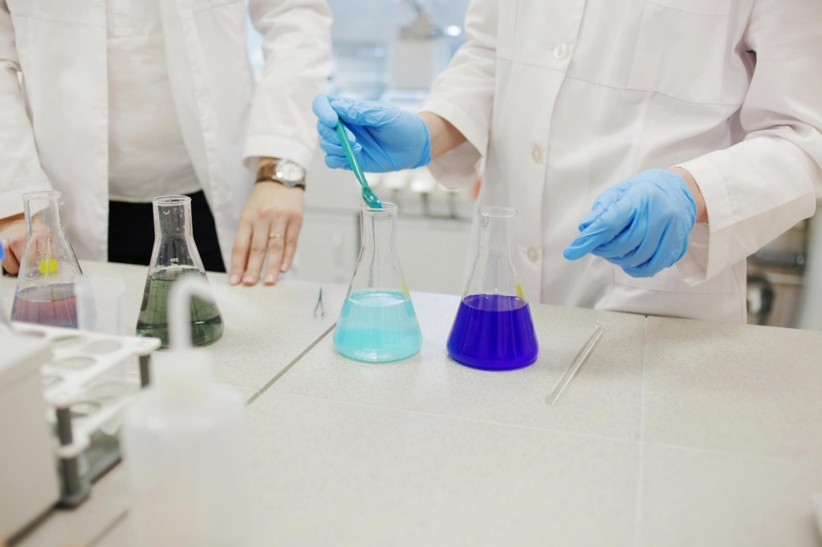 | 